EITHER DAY
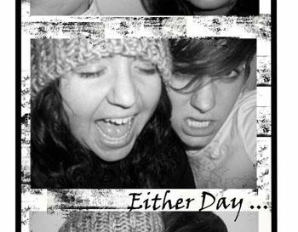

We are Tonia and Maegan, we are Either Day.
We have been creating music in different forms for well over 10 years, and have found joy in every word, every harmony.
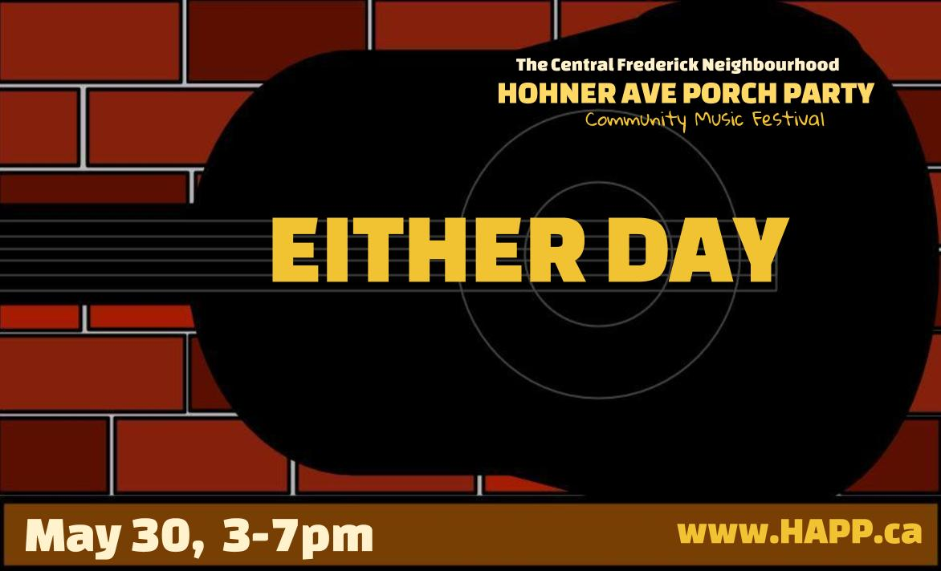
We create because creation breathes life into our hearts and we pray the same for you.

