ACOUSTIC STEEL
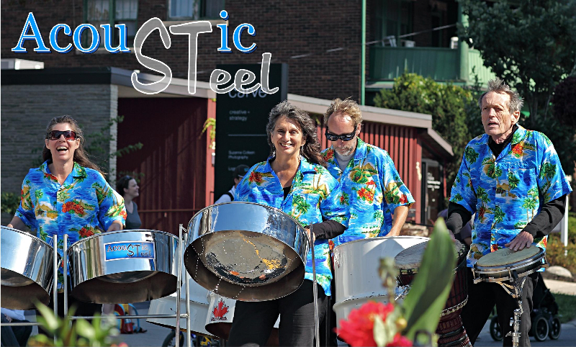
Acoustic Steel is a four member acoustic steel band. The musicians are Carol Taylor on first pan (melody); Cheryl Dietrich on double seconds (harmony); Rob Hartung on cello (bass), and Dick Smith, arranger, percussionist and vocalist. The band started playing together seven years ago and play a diverse selection of songs suited to the unique sound of the pan and rhythms of the Caribbean.

Events at which the band has been invited to play include Community Festivals, Charitable Fundraising Events, Weddings, private parties and Corporate functions.
