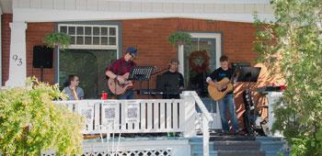
4 GUYS ON MATT’S PORCH

What do you get when you bring together a social worker, a commercial electrician, a music therapist, and a millwright?
4 Guys on Matt’s Porch...
...but when you give them a piano, acoustic guitar, bass, drums and three vocals, they cover a collection of bands from Mumford & Sons, Van Morrison, The Flamingos, The Beatles, Simon and Garfunkel, and other rockin music with our folk twist that is sure to keep you entertained!

